Introduction to Git
Git is a distributed version control system used to track and manage changes in source code and other project files. It helps developers maintain different versions of a project and collaborate with other team members.
Git was created by Linus Torvalds in 2005 for managing the development of the Linux kernel. Today, Git is widely used in software development, web development, mobile application development, data science, and open-source projects.
Unlike a centralized version control system, Git provides every developer with a complete local copy of the repository, including its history. Most Git operations can therefore be performed locally without requiring a continuous connection to a remote server. Git works with remote repository platforms such as GitLab, GitHub, and Bitbucket. These platforms provide additional facilities for collaboration, project management, code review, and continuous integration.

Features of Git
- Distributed Version Control
Git provides every developer with a complete copy of the repository and its history.
- Version Tracking
Git records changes made to project files and allows previous versions to be viewed or restored.
- Branching
Git allows developers to create separate branches for developing features, fixing bugs, or experimenting with changes.
- Merging
Changes made in different branches can be combined using the merge operation.
- Fast Performance
Most Git operations are performed locally, making Git fast and efficient.
- Collaboration
Multiple developers can work on the same project and share their changes through remote repositories.
- Data Recovery
Git maintains project history, allowing developers to recover earlier versions of files and commits.
- Remote Repository Support
Git can connect local repositories with remote repositories hosted on platforms such as GitLab and GitHub.
- Open Source
Git is free and open-source software.
- Secure Version History
Git uses cryptographic hashing to identify commits and maintain the integrity of the repository history.

Applications of Git
Git is used in various areas of software development and project management.
- Software Development
Git is used to manage source code and track changes throughout the software development process.
- Web Development
Developers use Git to manage the source code of websites and web applications.
- Mobile Application Development
Git is used to manage Android and iOS application source code.
- Team Projects
Git allows multiple developers to work on the same project using branches and remote repositories.
- Open-Source Development
Git supports distributed collaboration among developers working on open-source projects.
- DevOps
Git is commonly used as part of DevOps practices for source code management and automated build and deployment processes.
- Academic Projects
Students and researchers can use Git to maintain project source code, documentation, and different versions of their work.
- Data Science and Machine Learning
Git can be used to track source code, configuration files, notebooks, and other project-related files.
Git Life Cycle
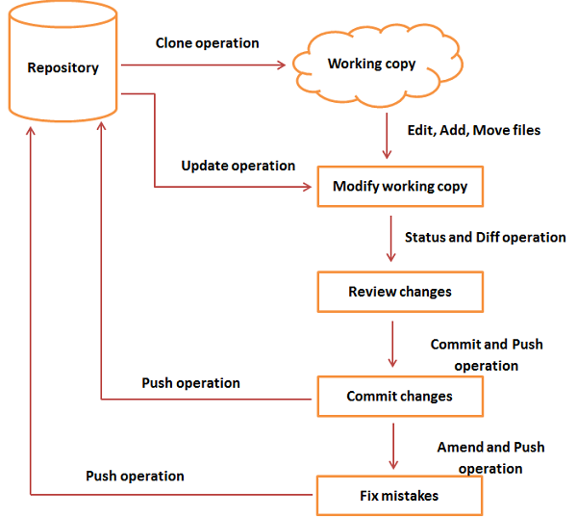
The Git life cycle describes the stages through which changes to project files pass before and after they are stored in a Git repository.
The main stages of the Git life cycle are:
Working Directory → Staging Area → Local Repository → Remote Repository
1. Working Directory
The working directory contains the files that are currently being developed or modified by the user. When a new file is created or an existing file is modified, the changes initially exist in the working directory.
2. Staging Area
The staging area contains the changes that have been selected for the next commit. The git add command is used to move changes from the working directory to the staging area.
git add filename
3. Local Repository
The local repository stores the committed changes and the complete version history of the project. The git commit command is used to record the staged changes in the local repository.
git commit -m "Commit message"
4. Remote Repository
A remote repository is a repository stored on a remote server. It is used for collaboration and sharing project changes with other developers. GitLab and GitHub are examples of platforms that host remote Git repositories.
The git push command transfers committed changes from the local repository to the remote repository.
git push
The git pull command downloads changes from the remote repository and integrates them into the local working environment.
git pull

